PASSPORT
FOR NC AHEC HEALTH CAREERS STUDENTS

North Carolina Area Health Education Centers

Welcome to the NC AHEC Health Careers Program Passport

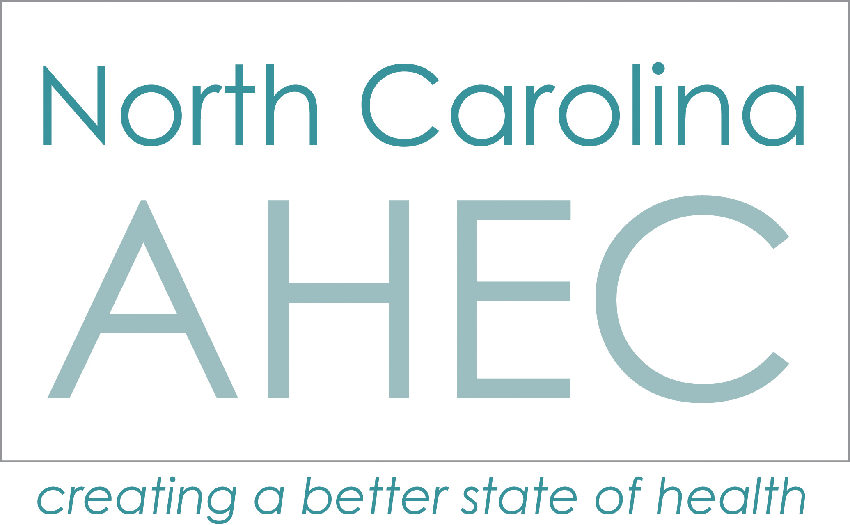
Welcome Aboard to the NC AHEC Health Careers PASSPORT Program! The NC AHEC Program was established to meet the state’s work and workforce needs by creating a pipeline for students across North Carolina to become academically prepared for a career in healthcare. We are also navigators who engage, educate, and provide exploration opportunities to pre-college students, parents, educators, and community to the many careers in the health care workforce.

By participating in the NC AHEC Passport Program, you have a unique opportunity to gain academic and enrichment hours towards a Certificate of Completion that is recognized by academic institutions and employers in North Carolina that sets you apart from other students in an increasingly competitive environment. The Passport Curriculum offers you the chance to document and collectively report all the health science, community service, and leadership activities you participate in as early as 8th grade.

Starting your journey is as easy as 1 -2 -3!

STEP 1: To activate this passport, please contact and gain prior approval from your AHEC Health Careers Director (see AHEC map below). Your Health Careers Director will be your tour guide to determine the best way to begin your journey through the Health Careers Programs offered by NC AHEC.
STEP 2: Complete the standardized registration form (application on next page).

STEP 3: Start participating in approved activities and documenting passport requirements. There are three categories: Educate, Explore and Engage. Read through the list of requirements to see which activities fit your career goals best to begin. Then work with your AHEC Health Careers Director to complete.

Step 1: Health Careers Director Approval

________________________________________ ____________________________________________
Printed Name Signature Date

Step 2: Complete the registration form below.

Registration Form

Student Name: ___________________________________________________________________________
First Middle Last

Begin Date: ______________________ Exit/Completion Date: ____________________________

AHEC Region: ___ Area L ___ Greensboro ___ South East
___ Charlotte ___ Mountain ___ Southern Regional
___ Eastern ___ Northwest ___ Wake

Health Career Interest(s): ___________________________________________________________________

Address: _________________________________________________________________________________

City: ____________________________________ State: ___________ Zip Code: ______________

County: ____________________ Date of Birth: ____/____/____ Age: ________

Parent(s) Email Address(es): ________________________________________________________________

Phone #: (h) ________________________ (c) _______________________________

Student Email Address: ____________________________________________________________________

Phone #: (h) ________________________ (c) _______________________________

Additional Phone Number(s): ______________________________________________________________

Circle one: Male or Female School: ______________________________________________________

Grade: ______ Graduation Year: _________ GPA: ________

Ethnicity (select one): ___ Hispanic ___ Non Hispanic

Registration Form (continued)

Race (select all that apply):
___ African American/Black ___ Asian
___ American Indian/Alaskan Native ___ Native Hawaiian/Other Pacific Islander
___ White

Can you answer yes to any of the following? Yes No
- You are (or will be) the first generation in your family to attend college.
- You have or currently receive Scholarship or Loan for Disadvantaged Students.
- While growing up, you or your family ever used federal or state assistance programs (such as: free or reduced school lunch, subsidized housing, food stamps, Medicaid etc.).
- While growing up, you lived where there were few medical providers at a convenient distance.

Parental Consent

________________________________________ ____________________________________________
Printed Name Signature Date

AHEC Health Careers Director Final Approval (once completed)

________________________________________ ____________________________________________
Printed Name Signature Date

Step 3: Check each Course, Activity or Event you have completed to meet the minimum requirements of each category. Complete the corresponding worksheets that follow to document your work. Please note that the Course, Activity or Events followed by an asterisk (*) are required.

Course, Activity, or Event | Yes? | No?
NC AHEC Health Careers Programming (40 hours minimum)
Cumulative Grade Point Average 3.0 or above
Grade(s) Event Completed
 | 8th | 9th | 10th | 11th | 12th
EDUCATE: Minimum 7
Knowledge of Health Ethics*
Knowledge of HIPAA Privacy Laws*
Knowledge of Professional Behavior*
Knowledge of Universal Precautions* (Handwashing/Gloving/ PPE)
Ability to Measure & Interpret Vital Signs (BP/Pulse/Temp)
CPR Certification
ACT Preparation Session
Advanced Mathematics Courses (AP or Honors)
Advanced Science Courses (AP or Honors)
Job Skills (Soft Skills)
Leadership Skills
Media & Technology Skills
Reading Comprehension Skills (EOC Score of 3 or higher)
SAT Preparation Session
EXPLORE: Minimum 4
Future Leaders in Healthcare Conference – AHEC
Health Care Provider speakers/presenters
Health Career Fair
Job Shadowing of Healthcare Professionals
University based programs, symposia, camps
Virtual Job Shadow website (member w/user ID)
ENGAGE: Minimum 2
Healthcare Related Service Learning/Healthcare Related Community Service (40 hours min)*
Health Career Club/Academies
Health Occupation Students of America (HOSA)
Healthcare Related Capstone Project or Senior Project
Peer Educator Training (i.e. Mental Health First Aid or other curriculum)
Summer & Weekend Programs/Events
Volunteer Service Award (100 hours min)
Youth Health Service Corps – AHEC
*Required. Activities must span two or more grade levels
Some programs are only available at select AHEC’s. Ask your Health Career Director for details.
Educate

In order to meet the requirements of the Educate section, the student must complete a minimum of 7 tasks and attach any required documentation.

Check Grade Event Completed
 | 8th | 9th | 10th | 11th | 12th
EDUCATE: Minimum 7
Knowledge of Health Ethics*
Name of program where this skill was acquired:
_______________________________________________________
Date(s) of Program: ______________________________________

Knowledge of HIPAA Privacy Laws*
Name of program where this skill was acquired:
_______________________________________________________
Date(s) of Program: ______________________________________

Knowledge of Professional Behavior*
Name of program where this skill was acquired:
_______________________________________________________
Date(s) of Program: ______________________________________

Knowledge of Universal Precautions*
Name of program where this skill was acquired:
_______________________________________________________
Date(s) of Program: ______________________________________

Ability to Measure & Interpret Vital Signs
Name of program where this skill was acquired:
_______________________________________________________
Date(s) of Program: ______________________________________

CPR Certification
Date(s):________________________________________________
Location:_______________________________________________
Instructor: ______________________________________________
ACT Preparation Sessions
Name of program where this skill was acquired:
_______________________________________________________
Date(s) of Program: ______________________________________

Advanced Mathematics Courses (AP or Honors)
Attach official transcript

Advanced Science Courses (AP or Honors)
Attach official transcript

Job Skills (Soft Skills)
Name of program where this skill was acquired:
_______________________________________________________
Date(s) of Program: ______________________________________

Leadership Skills
Name of program where this skill was acquired:
_______________________________________________________
Date(s) of Program: ______________________________________

Media & Technology Skills
Name of program where this skill was acquired:
_______________________________________________________
Date(s) of Program: ______________________________________

Reading Comprehension Skills
Name of program where this skill was acquired:
_______________________________________________________
Date(s) of program: ______________________________________
EOG Test Score: __________________________________________

SAT Preparation Sessions
Name of program where this skill was acquired:
_______________________________________________________
Date(s) of Program: ______________________________________

EXPLORE

In order to meet the requirements of the Explore section, the student must complete a minimum of 4 tasks and attach any required documentation.

Check Grade Event Completed
 | 8th | 9th | 10th | 11th | 12th
EXPLORE: Minimum 4
Future Leaders in Healthcare Conference – AHEC
Location of Conference:
_______________________________________________________
Date(s) of Conference: ______________________________________

Health Care Provider Speakers/Presenters
Name/location of program where this activity occurred:
_______________________________________________________
Date(s) of Program: ______________________________________
Topic/Theme of presentation:
_______________________________________________________

Health Career Fair
Location of event:
_______________________________________________________
Date(s) of Event: ______________________________________

Job Shadowing of Healthcare Professionals
Agency where shadowing experience occurred:
_______________________________________________________
Date(s) of Shadow experience: ______________________________________
Name and Occupation of Healthcare Professional Shadowed:
_____________________________________________________
_____________________________________________________

University based programs, symposia, camps
Name/location of this event/activity:
_______________________________________________________
Date(s) of Program: ______________________________________

Virtual Job Shadow website (member w/user ID)

Date(s) of membership: _____________________________________

ENGAGE

In order to meet the requirements of the Engage section, the student must complete a minimum of 2 tasks and attach any required documentation.

Check Grade Event Completed
 | 8th | 9th | 10th | 11th | 12th
ENGAGE: Minimum 2
Healthcare Related Service Learning/Healthcare Related Community Service (40 hours min)*
Attach volunteer log or report

Health Career Club/Academies
Location/Sponsor of Club/Academy:
_______________________________________________________
Date(s) of Participation: _____________________________________

Health Occupation Students of America (HOSA)
Level of Involvement:
_______________________________________________________
Name of HOSA Teacher/Counselor: ___________________________

HOSA Competitions & Conferences
Location(s):
_______________________________________________________
Date(s) of Competitions & Conferences: _______________________________________________________

Awards: _______________________________________________

Healthcare Related Capstone Project
Name/theme of project:
_______________________________________________________
Location/target population for project:
_______________________________________________________
Date(s) of Program: ______________________________________

Peer Educator Training
Location/sponsor of training:
_______________________________________________________
Date(s) of Training: ______________________________________
Attached documentation of completion

Summer & Weekend Programs/Events
Name of program/event:
_______________________________________________________
Location of program/event:
_______________________________________________________
Date(s) of Program: ______________________________________

Volunteer Service Award (100 hours min). Does not have to be healthcare related.
Date Received: ______________________________________

Youth Health Service Corps – AHEC
Location of Module Instruction:
_______________________________________________________
Name of Instructor: _______________________________________
Date(s) of Program: ______________________________________

Frequently Asked Questions

- How does the Passport benefit me?
The Passport gives you a comprehensive portfolio of all the academic and enrichment programs and activities on your journey to a health career! It can be used as part of your college applications, scholarship applications, and interviews.

- I have completed the application. Now what?
Once you have completed all of the requirements, return to your Health Careers Director for final approval. They will check for accuracy and coordinate the details regarding awards, recognition, and securing the letter of congratulations from the NC AHEC Director.

- How will I be recognized?
All certificate completers will be recognized during our annual Future Leaders in Healthcare Conference (if you are not able to come to the conference, you may make arrangements with your Health Careers Director to receive your certificate of completion). You will receive a NC AHEC Health Careers Certificate of Completion and letter of recommendation from the Director of the NC AHEC Program.

- When can I begin to complete the requirements?
You can count activities as early as 8th grade and they must span over at least 2 years.

- What if I am not a NC AHEC Program participating student? Can I still get a certificate of completion? No. You have to complete at least 40 hours of approved AHEC programming as part of the requirements.

- Can I include this certificate of completion on college applications? Absolutely and we highly encourage it. Our partners across the state are aware of this certificate and would be delighted to see it on an application.

- I have completed an event in multiple grades (ie. AP Math), can I count that event more than once towards the minimum requirement? No. You may check as many boxes in that row as appropriate but will only count once towards your minimum requirement.

If you have any other questions, please contact your AHEC Health Careers Director.

Alice J. Schenall
252-972-6958
alice.schenall@arealahec.org

Director of Student Services

